Faculty:
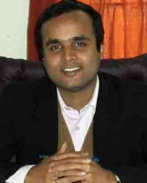
Dr. Anup Dandapat
Dean (Academic Affairs)
Associate Professor, Department of Electronics & Communication Engineering
Ph.D (Jadavpur University)
Senior Member, IEEE
Research Interests:
- Low Power VLSI
- Low Power Digital Circuits
- Low Power High Speed Multipliers
E-mail: anup.dandapat@gmail.com

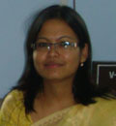

Mrs. Bishnulatpam Pushpa Devi

Assistant Professor

Research Interests:
Image processing
E-mail: Bishnulatpam.Pushpa@nitm.ac.in
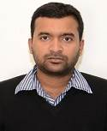

Dr. Vinay Kumar

Assistant Professor

Ph.D in Digital VLSI Design from NIT Meghalaya

M.Tech in Microelectronics & VLSI Design from NIT Silchar

B.Tech in Electronics & Communication Engineering from NERIST

Research Interests:
- Low Power VLSI Design
- Approximate Computing
- CMOS Image Sensors
E-mail:
vinay.kumar@nitm.ac.in
vinaynits@gmail.com
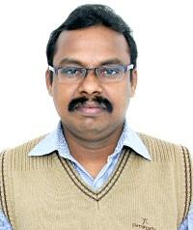

Dr. Ch V Rama Rao

Asst. Professor

Ph.D., JNTUH - Speech Processing

M.Tech., JNTUH - Digital Systems and Computer Electronics

B.Tech., Acharya Nagarjuna University - ECE
Research Interests:
- Statistical Signal, Image and Speech Processing
- Pattern recognition
- Design and development of advanced communication systems
E-mail:
chvramarao@nitm.ac.in
chvramaraogec@gmail.com
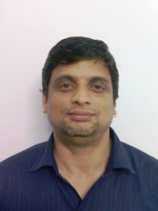

Dr. P. Rangababu

Assistant Professor

Ph.D- Hyderabad Central University, Hyderabad

Research Interests:
- FPGA-based Embedded Systems for Multimedia and DSP Applications
- VLSI Chip Design, Crypto-Processors
- Memristors, Reconfigurable Systems for Medical Diagnosis
E-mail:
p.rangababu@nitm.ac.in
p.rangababu@gmail.com

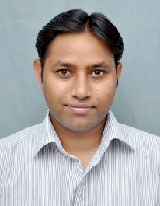

Dr. Pradeep Kumar Rathore

Assistant Professor

Ph.D., IIT Delhi - CMOS MEMS Integrated Sensors

M.Tech., Tezpur University - Electronics Design & Technology

B.Tech., NERIST - Electronics & Communication Engg.

Research Interests:
- CMOS-MEMS based Sensors
- Microfabrication and Micromachining Technology
- Semiconductor Device Fabrication Technology
E-mail:
rpradeep.tu@gmail.com
pradeeprathore@nitm.ac.in



Dr. Prabir Kumar Saha

Assistant Professor

IIEST

Tezpur University

AMIETE

Research Interests:
- VLSI Design
- Computer Arithmetic
- Digital Signal Processing
E-mail:
prabir.saha@nitm.ac.in
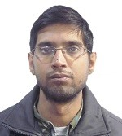

Mr. Abhishek Sarkhel

Assistant Professor

Ph.D in Electromagnetism (Pursuing)

ME in Communication Engineering

B.Tech in Electronics and Communication Engineering

Research Interests:
- Artificial Materials
- Microwave Antennas
E-mail:
abhishek.sarkhel@nitm.ac.in
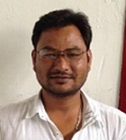

Mr. Mridupawan Sonowal

Assistant Professor

Ph.D, (IIT Guwahati, pursuing)

M.Tech (IIT Guwahati)

B.E (A.E.C)

Research Interests:
- Information theory and coding

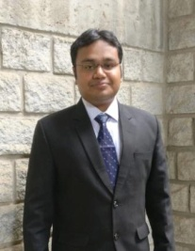

Dr. Shubhankar Majumdar

Assistant Professor

Ph.D. - Indian Institute of Technology, Kharagpur

M.Tech.

B.E. - University Institute of Technology (UIT), Bhopal

Research Interests:
- RF, High Speed and Power Semiconductor Devices
- VLSI circuit design and Modelling (Device to circuit interfacing)
- Low cost Energy efficient system for Agriculture & Health Sector
E-mail:
shub@nitm.ac.in

